Project Development Phase Model Performance Test

|  |  |
| --- | --- |
| Date | 14 November 2022 |
| Team ID | PNT2022TMID27543 |
| Project Name | Emerging Methods for Early Detection of Forest Fires |
| Maximum Marks | 10 Marks |

# Model Performance Testing:

Project team shall fill the following information in model performance testing template.

|  |  |  |
| --- | --- | --- |
| **S.No.** | **Parameter** | **Values** |
| 1. | Model Summary | Total params: 19,052,397  Trainable params: 19,052,397  Non-trainable params: 0 |
| 2. | Accuracy | Training Accuracy – 92.43  Validation Accuracy – 97.52 |

# Screenshot: Model Summary:

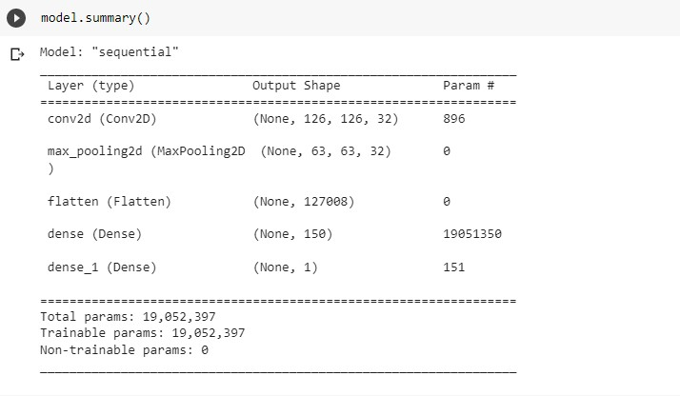

**Accuracy:**

